**Go Back N ARQ**

**Question:**

Write the program of Sender and Receiver using socket program to implement the sliding window feature. The Program will implement the Go Back N ARQ or the Selective Repeat ARQ. It will send an acknowledgement whenever the program will receive the binary bit. Then if the acknowledgement is not received by the sender it will retransmit the whole frame.

Language Used - Python

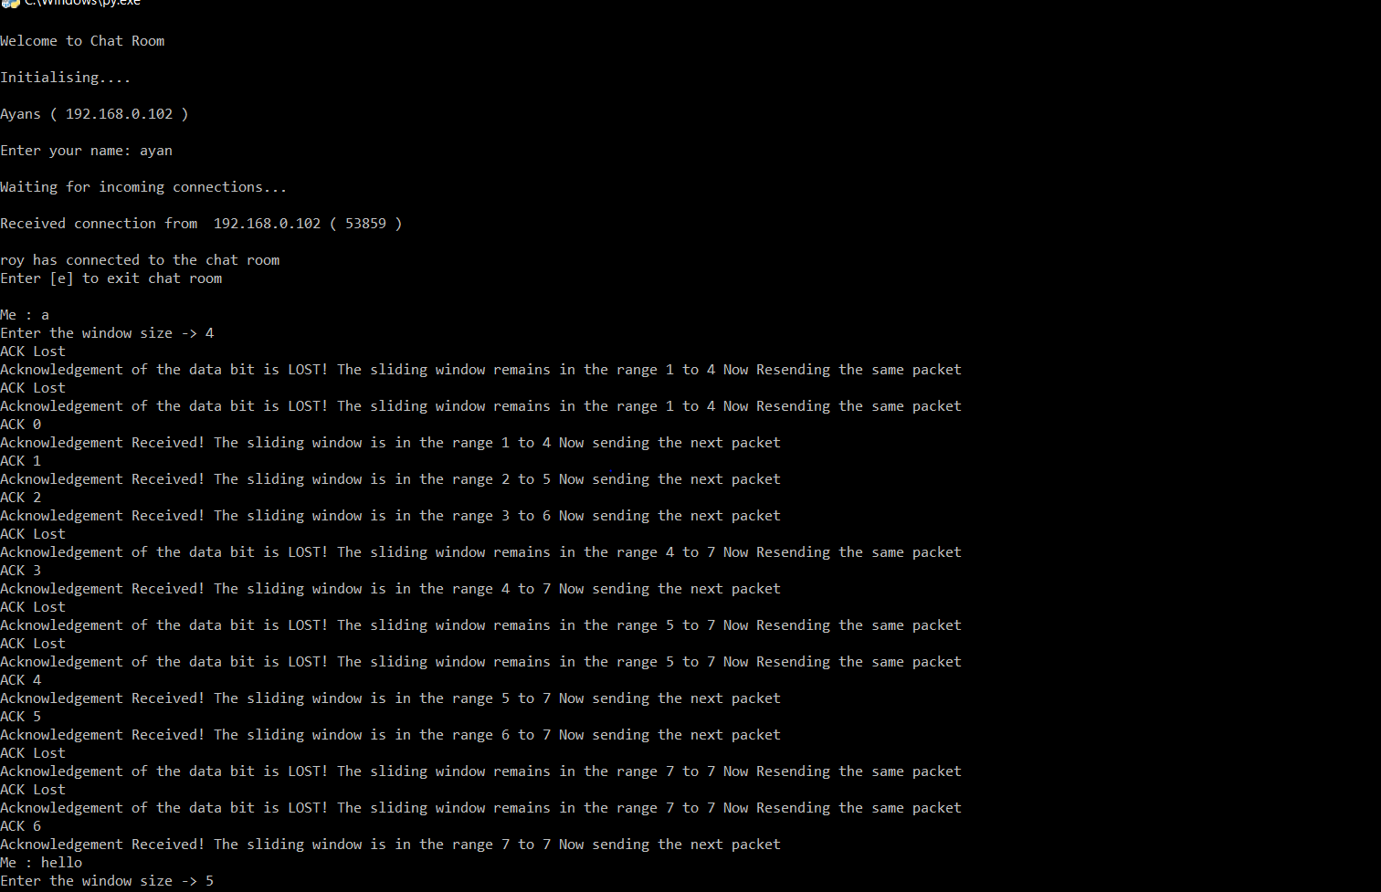**Output 1(Sender side) :**

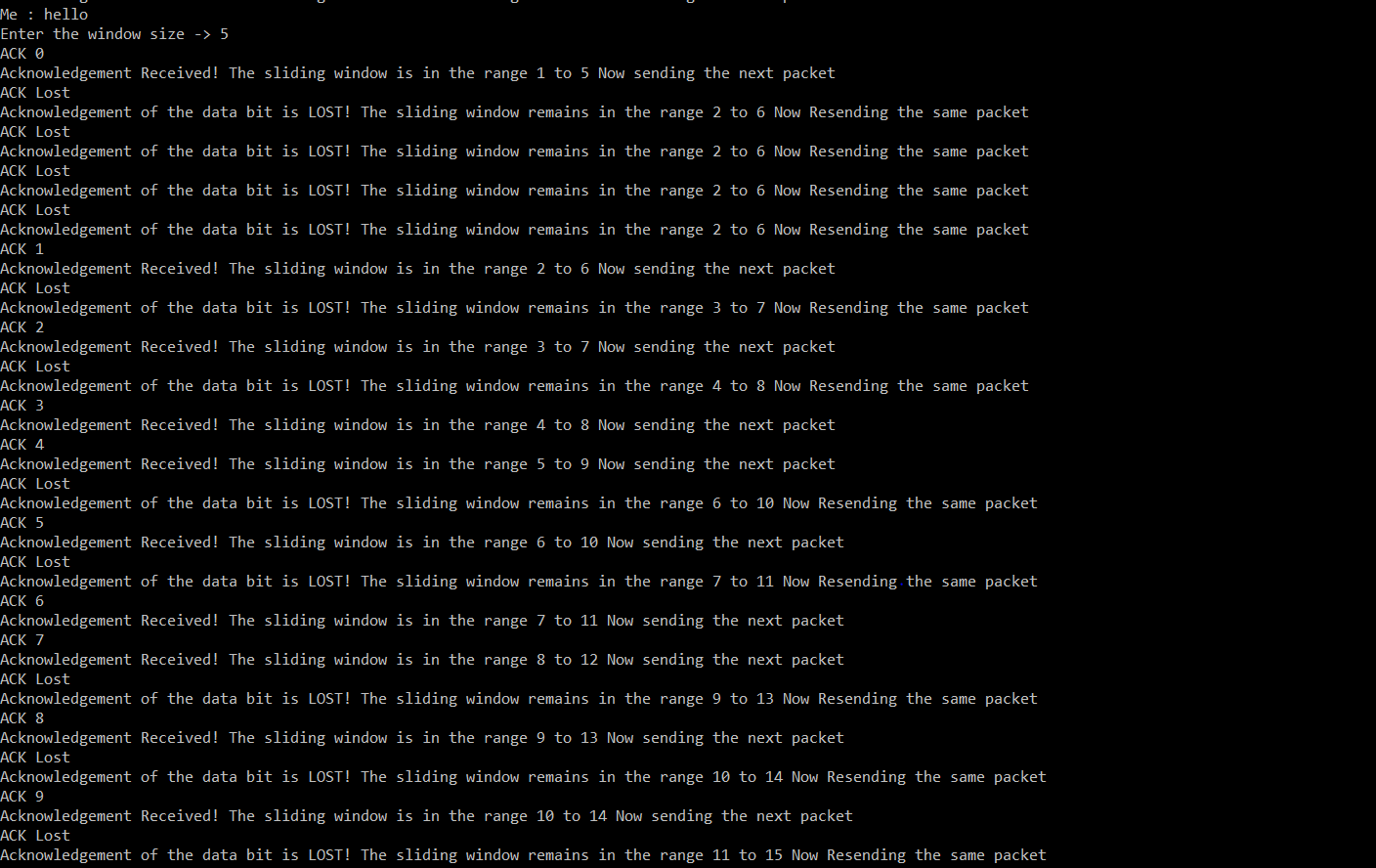

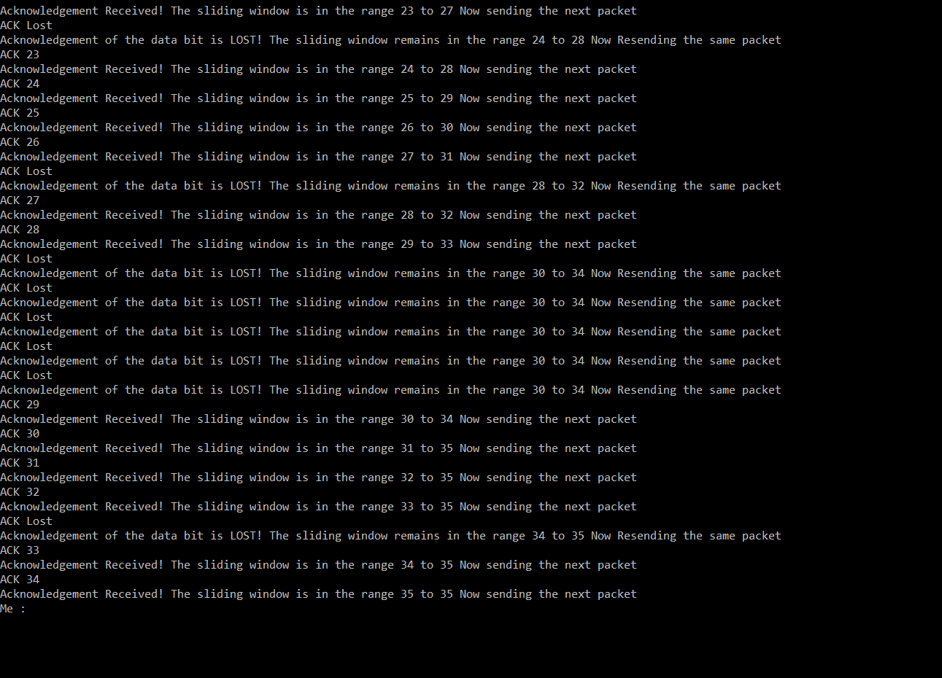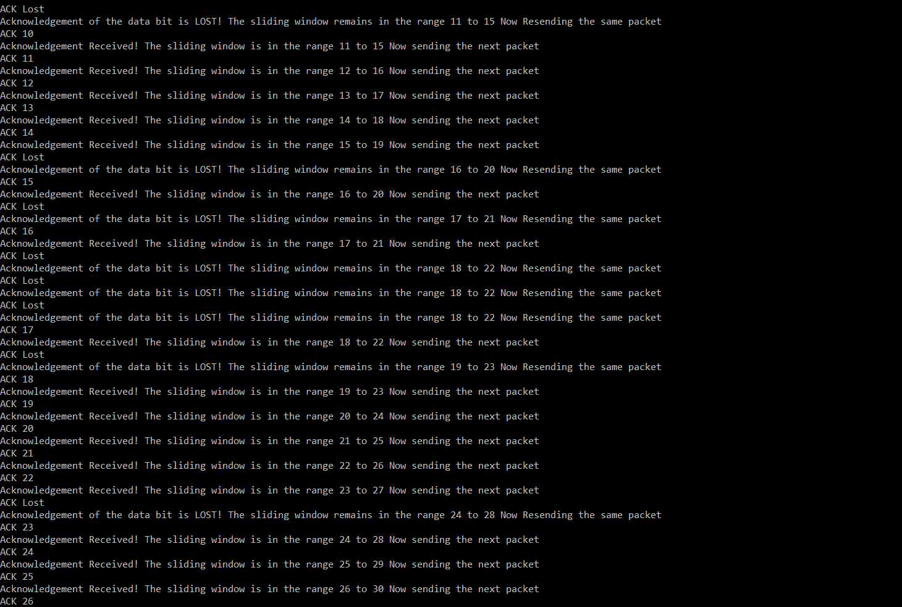

**Output 2(Receiver side):**

